**Business Challenge:**

Every year the prices on products increase and these new prices are to be updated on the Contracts. Any new Purchase orders created to purchase goods from the Vendor needs to have the updated prices.

Business users used to take couple of days each to carry out this update every year.

**Solution:**

As part of the support role IT team then started to update the prices on Contracts in Mass, which was also time consuming. This was done every year for thousands of materials.

Team identified this to be a recurring issue and worked towards improving the process, which will be benefiting the business. Team proactively developed a custom program in SAP where the prices can be listed in an excel sheet and uploaded within minutes.

Using this custom program, business can now update multiple contracts at once and the upload takes only few minutes irrespective of the number of lines. This has given business full control on the price update activity without depending on the support team.

**Business Benefit:**

* Business can self-update the data , with no dependency on the Support Team
* Efforts reduced from ~2 hrs to 5 min.
* Tickets reduction up to ~20 per year
* Increase accuracy and efficiency

**Transaction Code: ZFFR22407**

Below are the steps to update the prices-

**Step 1**: Keep the Excel file to be uploaded ready in the below format.

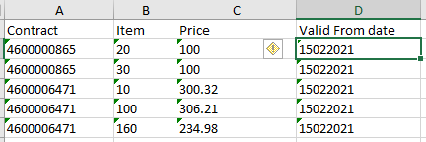

**Step 2**: Go to the Transaction code ZFFR22407

Browse the file and click Execute

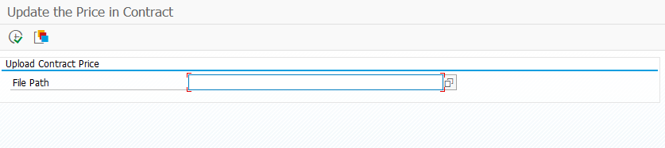

**Step3**: System will update the prices and will display if there are any errors along with the Contract number and the line item.

Click “Back” to get the error details

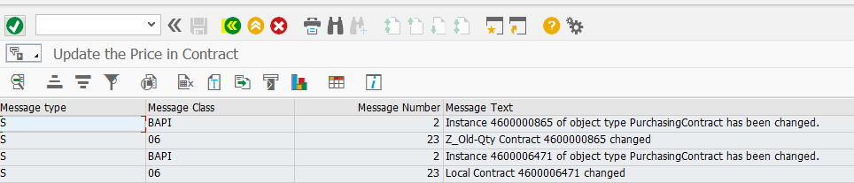

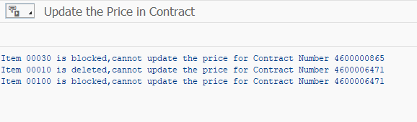

**Step 4**: If the Format in excel is incorrect, request to correct it and try re-uploading.

If the issue persists, create a ticket by contacting the service desk

Possible messages that we receive after executing the Program are as below-

|  |
| --- |
| **Possible messages** |
| Item 00010 is blocked, cannot update the price |
| Line item 01190 does not exists |
| Date format is Invalid for Item 00050 |
| Item 000100 is deleted, cannot update the price |